Flowchart

From Wikipedia, the free encyclopedia
A flowchart is a common type of chart, that represents an algorithm or process, showing the steps as boxes of various kinds, and their order by connecting these with arrows. Flowcharts are used in analyzing, designing, documenting or managing a process or program in various fields.
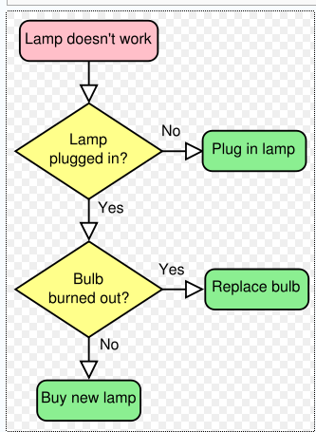

Examples

1. Input Output
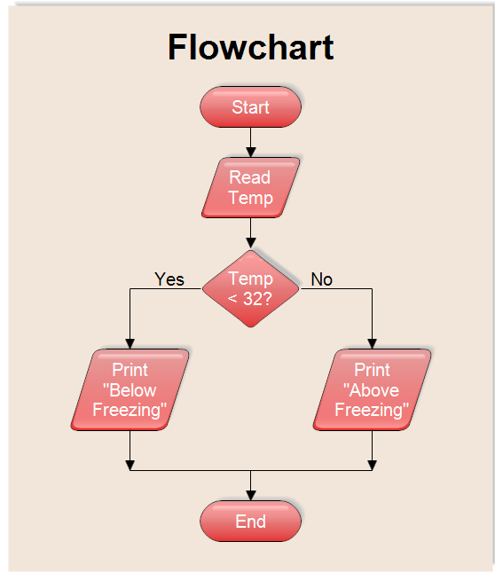

2. Financial Crisis
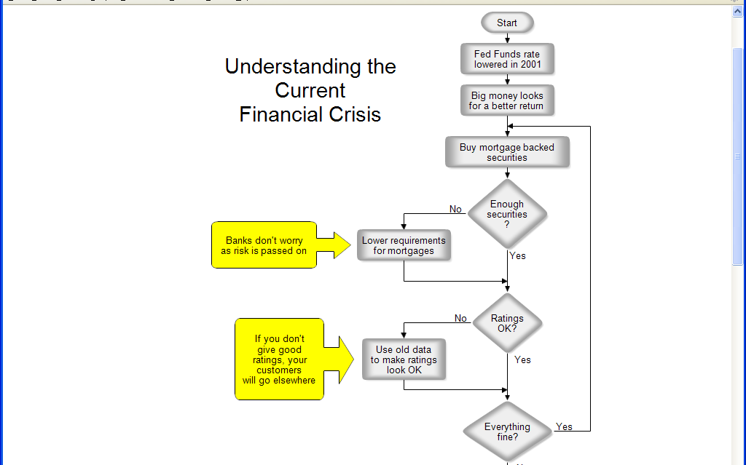
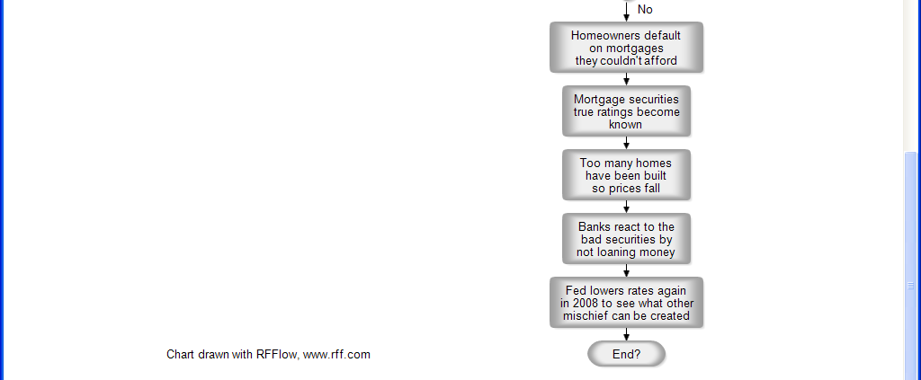

Understanding the Current Financial Crisis
This flowchart tries to explain the basic points in the current mortgage crisis. The story is probably an old one. People try to get the maximum return on their money. Big returns have big risk. Investors may not have realized this, but the risk was there. The two yellow boxes in the chart above show where regulation failed. Normally a bank wouldn't give a loan to someone who had no income and no assets and such mortgages combined together should not have a high rating. By elevating these toxic mortgages to triple A an enormous amount of wealth was generated. However, this wealth disappeared when their true value was determined. This will all happen again, but in a different way.
3. Order Processing

